**S1.** Simulations of the zero-inflated GAMM models checked against raw data means and variance for the effect of age. Since the true values fall within the confidence intervals for the model predictions, this indicates this modeling technique was appropriate for our data distribution.

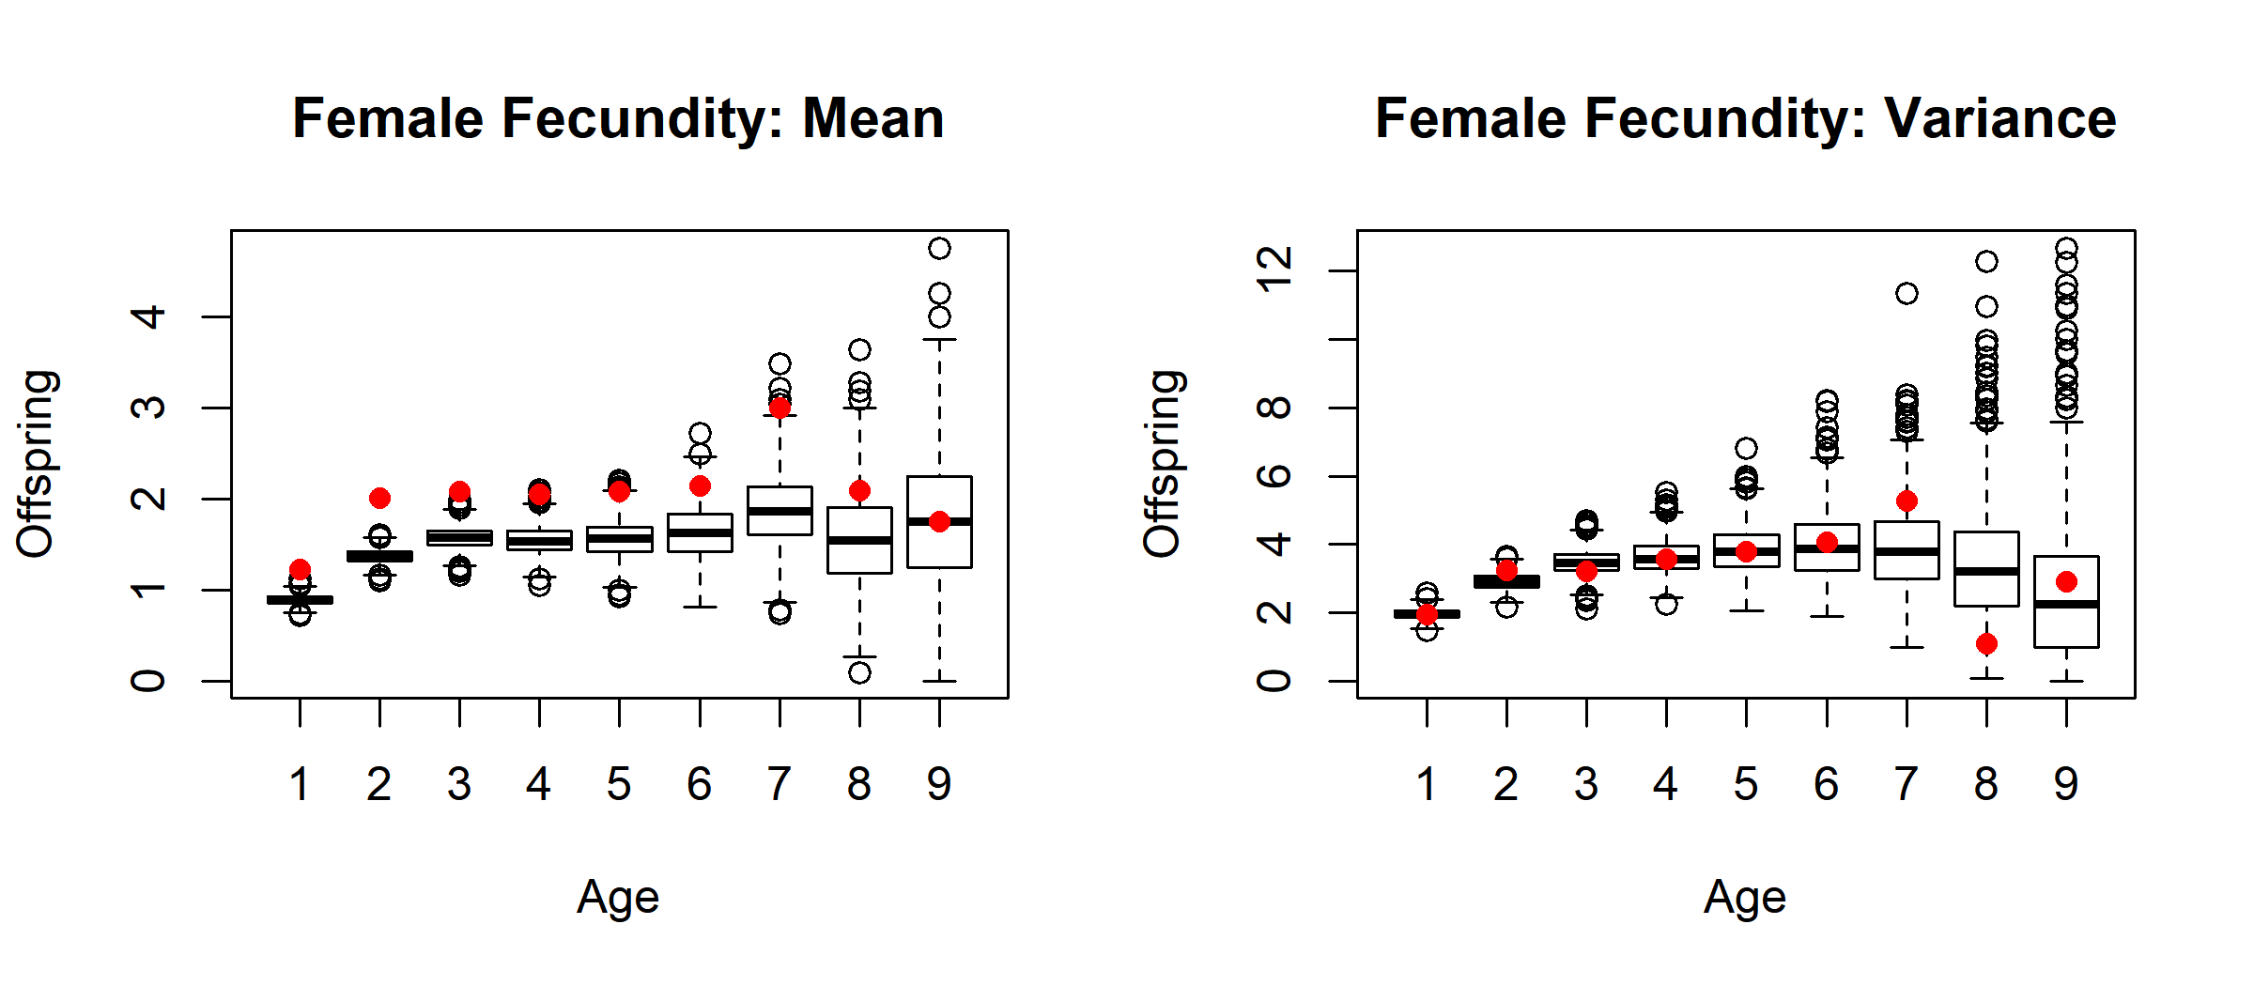

**Figure S1a.** Boxplots of predicted means and variance of female fecundity in 1000 simulations of the GAMM model. Red dots represent the raw means and variance for every age class.

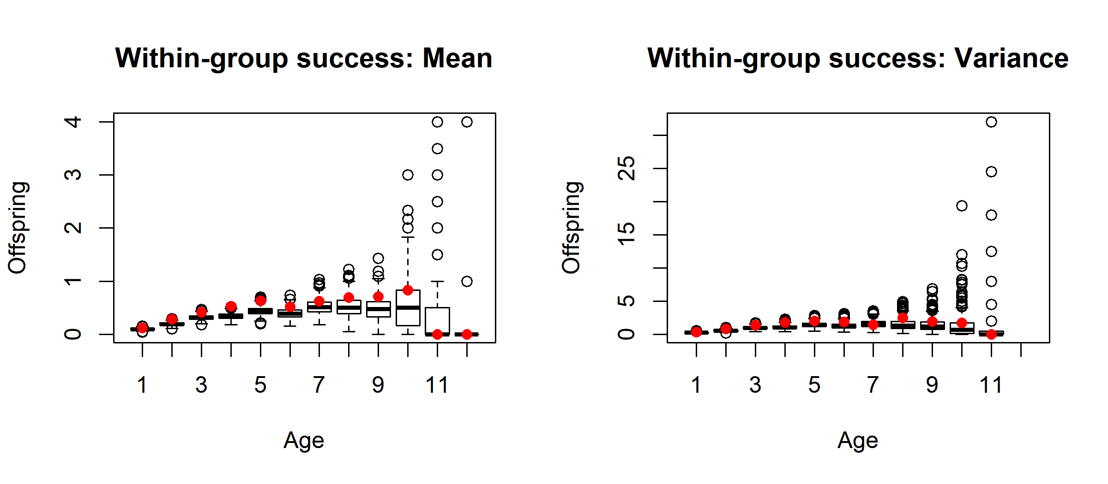

**Figure S1b.** Boxplots of predicted means and variance of extra-group mating success in males in 1000 simulations of the GAMM model. Red dots represent the raw means and variance for every age class.

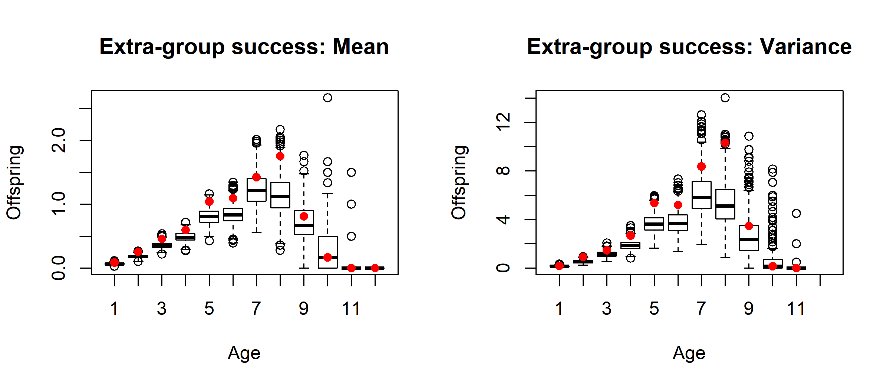

**Figure S1c.** Boxplots of predicted means and variance of extra-group mating success in males in 1000 simulations of the GAMM model. Red dots represent the raw means and variance for every age class.

|  |  |  |  |
| --- | --- | --- | --- |
| Trait | Lifespan Spline EDF | | P-value |
| *Female breeding start date* | 1.015 | 0.43 | |
| *Female clutch size* | 1.000 | 0.19 | |
| Female fecundity |  |  | |
| *Probability* | 2.036 | 0.14 | |
| *Number* | 1.366 | 0.38 | |
| *Male moult date* | 1.011 | 0.40 | |
| Male within-group success |  |  | |
| *Probability* | 2.025 | 0.40 | |
| *Number* | 1.001 | 0.41 | |
| Male extra-group success |  |  | |
| *Probability* | 1.000 | 0.50 | |
| *Number* | 1.003 | 0.25 | |

**Figure S2.** Effective degrees of freedom (EDF) and p-value associated with the spline effect of lifespan in the GAMM for each trait. Additional spline and parametric terms in each model are denoted in figures S4-S12 and the estimates and statistics for these covariates are not notably different than those reported there.

|  |  |  |  |
| --- | --- | --- | --- |
| Trait | Final year alive [yes] | | P-value |
| *Female breeding start date* | -2.615 | 0.06 | |
| *Female clutch size* | -0.010 | 0.13 | |
| Female fecundity |  |  | |
| *Probability* | -0.293 | 0.32 | |
| *Number* | -0.028 | 0.88 | |
| *Male moult date* | -0.822 | 0.56 | |
| Male within-group success |  |  | |
| *Probability* | -0.346 | 0.41 | |
| *Number* | -0.487 | 0.29 | |
| Male extra-group success |  |  | |
| *Probability* | 0.324 | 0.37 | |
| *Number* | -0.417 | 0.16 | |

**Figure S3.** Estimated and associated p-value for the parametric binomial effect of final year of life (yes or no) in the GAMM for each trait. Additional spline and parametric terms in each model are denoted in figures S4-S12 and the estimates and statistics for these covariates are not notably different than those reported there. Models which include a fixed effect denoting death during the breeding season have this effect nested within the effect of final year of life.

**Table S4** Results from a zero-inflated GAMM predicting annual number of offspring reaching independence for females. EDF is the effective degrees of freedom and Ref. DF is the reference degrees of freedom for the relevant spline term. Terms in the probability portion of the zero-inflated model are denoted by (p) and terms in the numbered count portion are denoted by (n). ‘Death’ is a binomial term denoting if the individual died before the end of the breeding season.

|  |  |  |  |  |
| --- | --- | --- | --- | --- |
| **Spline Terms** | **EDF** | **Ref. DF** | **Chi squared** | **P-value** |
| Age (p) | 4.421 | 5.305 | 42.154 | < 0.001 |
| Age (n) | 3.325 | 4.119 | 20.465 | < 0.001 |
| **Parametric Terms** | **Estimate** | **Standard Error** | **Z-value** | **P-value** |
| Intercept (p) | 0.063 | 0.110 | 0.575 | 0.565 |
| Longevity (p) | 0.038 | 0.024 | 1.564 | 0.118 |
| Death [yes] (p) | -0.998 | 0.138 | -7.245 | < 0.001 |
| Intercept (n) | 0.793 | 0.076 | 10.374 | < 0.001 |
| Longevity (n) | 0.017 | 0.015 | 1.118 | 0.264 |
| Death [yes] (n) | -0.114 | 0.097 | -1.175 | 0.240 |

Note: The deviance explained by the model is 15.6%. The sample size is 1558. The model includes random effects of year (n =28, variance (n) = 0.050, variance (p) = 0.066 ), and individual (n = 678, variance (n) = 1 x 10-8, variance (p) = 0.083) for both numerical and probability portions.

**Table S5** Results from a zero-inflated GAMM predicting annual number of within-group offspring sired by males. EDF is the effective degrees of freedom and Ref. DF is the reference degrees of freedom for the relevant spline term. Terms in the probability portion of the zero-inflated model are denoted by (p) and terms in the numbered count portion are denoted by (n). ‘Status’ is a binomial term denoting whether the male was a dominant or helper during that year’s breeding season. ‘Death’ is a binomial term denoting if the individual died before the end of the breeding season.

|  |  |  |  |  |
| --- | --- | --- | --- | --- |
| **Spline Terms** | **EDF** | **Ref. DF** | **Chi squared** | **P-value** |
| Age (p) | 2.417 | 3.006 | 5.695 | 0.128 |
| Age (n) | 1.002 | 1.003 | 0.089 | 0.768 |
| **Parametric Terms** | **Estimate** | **Standard Error** | **Z-value** | **P-value** |
| Intercept (p) | -4.925 | 0.709 | -6.950 | < 0.001 |
| Longevity (p) | 0.016 | 0.041 | 0.400 | 0.689 |
| Status [dominant] (p) | 1.873 | 0.196 | 9.557 | < 0.001 |
| Death [yes] (p) | -1.199 | 0.356 | -3.370 | < 0.001 |
| Intercept (n) | -0.002 | 0.260 | -0.006 | 0.995 |
| Longevity (n) | 0.028 | 0.034 | 0.821 | 0.412 |
| Status [dominant] (n) | 0.552 | 0.213 | 2.585 | 0.010 |
| Death [yes] (n) | -0.203 | 0.368 | -0.550 | 0.582 |

Note: The deviance explained by the model is 50.8%. The sample size is 2511. The model includes random effects of year (n =28, variance (n) = 0.004, variance (p) = 10.772), and individual (n = 898, variance (n) = 0.278, variance (p) = 0.237) for both numerical and probability portions.

**Table S6** Results from a zero-inflated GAMM predicting annual number of extra-group offspring sired by males. EDF is the effective degrees of freedom and Ref. DF is the reference degrees of freedom for the relevant spline term. Terms in the probability portion of the zero-inflated model are denoted by (p) and terms in the numbered count portion are denoted by (n). ‘Status’ is a binomial term denoting whether the male was a dominant or helper during that year’s breeding season. ‘Death’ is a binomial term denoting if the individual died before the end of the breeding season.

|  |  |  |  |  |
| --- | --- | --- | --- | --- |
| **Spline Terms** | **EDF** | **Ref. DF** | **Chi squared** | **P-value** |
| Age (p) | 3.491 | 4.287 | 42.300 | < 0.001 |
| Age (n) | 4.650 | 5.519 | 46.590 | < 0.001 |
| **Parametric Terms** | **Estimate** | **Standard Error** | **Z-value** | **P-value** |
| Intercept (p) | -4.205 | 0.780 | -5.391 | < 0.001 |
| Longevity (p) | 0.031 | 0.046 | 0.675 | 0.500 |
| Status [dominant] (p) | 0.172 | 0.164 | 1.049 | 0.294 |
| Death [yes] (p) | -0.890 | 0.316 | -2.816 | 0.005 |
| Intercept (n) | 0.961 | 0.182 | 5.272 | < 0.001 |
| Longevity (n) | -0.038 | 0.033 | -1.147 | 0.251 |
| Status [dominant] (n) | -0.245 | 0.125 | -1.957 | 0.050 |
| Death [yes] (n) | 0.060 | 0.213 | 0.283 | 0.777 |

Note: The deviance explained by the model is 52.6%. The sample size is 2511. The model includes random effects of year (n =28, variance (n) = 0.021, variance (p) = 13.153), and individual (n = 898, variance (n) = 0.199, variance (p) = 0.541) for both numerical and probability portions.

**Table S7** Results from GAMM predicting female clutch size. EDF is the effective degrees of freedom and Ref. DF is the reference degrees of freedom for the relevant spline term.

|  |  |  |  |  |
| --- | --- | --- | --- | --- |
| **Spline Terms** | **EDF** | **Ref. DF** | **F-value** | **P-value** |
| Age | 4.295 | 5.193 | 16.744 | < 0.001 |
| Incubation date | 6.121 | 7.185 | 64.126 | < 0.001 |
| **Parametric Terms** | **Estimate** | **Standard Error** | **t-value** | **P-value** |
| Intercept | 1.140 | 0.009 | 121.568 | < 0.001 |
| Longevity | 0.003 | 0.002 | 1.531 | 0.126 |

Note: The model R2 (adjusted) is 0.22 and sample size is 3865. The model includes random effects of year (n =28, variance = 1.3 x 10-12), and individual (n = 979, variance = 0.003).

**Table S8** Results from GAMM predicting female breeding start date. EDF is the effective degrees of freedom and Ref. DF is the reference degrees of freedom for the relevant spline term.

|  |  |  |  |  |
| --- | --- | --- | --- | --- |
| **Spline Terms** | **EDF** | **Ref. DF** | **F-value** | **P-value** |
| Age | 5.856 | 6.706 | 72.79 | < 0.001 |
| **Parametric Terms** | **Estimate** | **Standard Error** | **t-value** | **P-value** |
| Intercept | 11.016 | 1.294 | 8.517 | < 0.001 |
| Longevity | -0.270 | 0.337 | -0.802 | 0.423 |

Note: The model R2 (adjusted) is 0.56 and sample size is 1089. The model includes random effects of year (n =28, variance = 3.5 x 10-8), and individual (n = 678, variance = 80.515).

**Table S9** Results from GAMM predicting male moult date. EDF is the effective degrees of freedom and Ref. DF is the reference degrees of freedom for the relevant spline term.

|  |  |  |  |  |
| --- | --- | --- | --- | --- |
| **Spline Terms** | **EDF** | **Ref. DF** | **F-value** | **P-value** |
| Age | 5.749 | 6.712 | 165.387 | < 0.001 |
| **Parametric Terms** | **Estimate** | **Standard Error** | **t-value** | **P-value** |
| Intercept | -31.430 | 2.343 | -13.415 | < 0.001 |
| Longevity | 0.207 | 0.435 | 0.475 | 0.635 |
| Status [dominant] | -9.084 | 1.548 | -5.870 | < 0.001 |

Note: The model R2 (adjusted) is 0.61 and sample size is 2116. The model includes random effects of year (n =28, variance = 50.70), and individual (n = 1024, variance = 170.32).

**Table S10** Results from GAMM predicting annual female survival probability. EDF is the effective degrees of freedom and Ref. DF is the reference degrees of freedom for the relevant spline term.

|  |  |  |  |  |
| --- | --- | --- | --- | --- |
| **Spline Terms** | **EDF** | **Ref. DF** | **Chi squared** | **P-value** |
| Age | 1.000 | 1.000 | 15.969 | < 0.001 |
| **Parametric Terms** | **Estimate** | **Standard Error** | **Z-value** | **P-value** |
| Intercept | 59.870 | 12.960 | 4.620 | < 0.001 |

Note: The model R2 (adjusted) is 0.05 and sample size is 1896. The model includes random effects of year (n =29, variance = 0.22 ), and individual (n = 979, variance = 1 x 10-7).

**Table S11** Results from GAMM predicting annual male survival probability. EDF is the effective degrees of freedom and Ref. DF is the reference degrees of freedom for the relevant spline term.

|  |  |  |  |  |
| --- | --- | --- | --- | --- |
| **Spline Terms** | **EDF** | **Ref. DF** | **Chi squared** | **P-value** |
| Age | 1.001 | 1.002 | 29.15 | < 0.001 |
| **Parametric Terms** | **Estimate** | **Standard Error** | **Z-value** | **P-value** |
| Intercept | 45.983 | 12.419 | 3.703 | < 0.001 |
| Status [dominant] | -0.191 | 0.103 | -1.853 | 0.064 |

Note: The model R2 (adjusted) is 0.056 and sample size is 2747. The model includes random effects of year (n =29, variance = 0.21 ), and individual (n = 979, variance = 3.01 x 10-4).